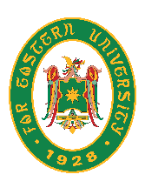
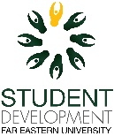
Far Eastern University
Office of Student Development

LETTER OF ENDORSEMENT

CURRENT DATE

Dear Philtrust Bank - Morayta,

This is to formally endorse the application for transfer of bank signatories of the NAME OF ORGANIZATION, an accredited student organization of Far Eastern University for SY 2022-2023.

We will greatly appreciate the kind assistance that will be accorded to them in their request.

Thank you so much.

Graciel A. Lintag
Director, Student Development
glintag@feu.edu.ph

